# C# Object Oriented Programming – Self-Starter Kit for Fresher’s

## : C# Object Oriented Programming& .NET Framework Concepts

|  |  |
| --- | --- |
| **C# Object Oriented Programming and .NET Framework eLearning Links** | |
| Top of Form  **Basic OOPS Concepts**Bottom of Form | <http://msdn.microsoft.com/en-us/library/dd460654.aspx> |
| **Inheritance** | [http://msdn.microsoft.com/en-us/library/ms173149(v=vs.110).aspx](http://msdn.microsoft.com/en-us/library/ms173149%28v=vs.110%29.aspx) |
| **Polymorphism** | [http://msdn.microsoft.com/en-us/library/ms173152(v=vs.110).aspx](http://msdn.microsoft.com/en-us/library/ms173152%28v=vs.110%29.aspx) |
| **Abstract and Sealed Class** | [http://msdn.microsoft.com/en-us/library/ms173150(v=vs.110).aspx](http://msdn.microsoft.com/en-us/library/ms173150%28v=vs.110%29.aspx) |
| **C# Modifiers** | [http://msdn.microsoft.com/en-us/library/6tcf2h8w(v=vs.110).aspx](http://msdn.microsoft.com/en-us/library/6tcf2h8w%28v=vs.110%29.aspx) |
| **C# Access modifiers** | [http://msdn.microsoft.com/en-us/library/wxh6fsc7(v=vs.110).aspx](http://msdn.microsoft.com/en-us/library/wxh6fsc7%28v=vs.110%29.aspx) |
| **C# Types** | [http://msdn.microsoft.com/en-us/library/3ewxz6et(v=vs.110).aspx](http://msdn.microsoft.com/en-us/library/3ewxz6et%28v=vs.110%29.aspx) |
| **C# Delegates** | [http://msdn.microsoft.com/en-us/library/ms173171(v=vs.110).aspx](http://msdn.microsoft.com/en-us/library/ms173171%28v=vs.110%29.aspx) |
| **C# Generics** | [http://msdn.microsoft.com/en-us/library/512aeb7t(v=vs.110).aspx](http://msdn.microsoft.com/en-us/library/512aeb7t%28v=vs.110%29.aspx) |
| **C# Class and Structs** | [http://msdn.microsoft.com/en-us/library/ms173109(v=vs.110).aspx](http://msdn.microsoft.com/en-us/library/ms173109%28v=vs.110%29.aspx) |
| **C# Static class and members** | [http://msdn.microsoft.com/en-us/library/98f28cdx(v=vs.110).aspx](http://msdn.microsoft.com/en-us/library/98f28cdx%28v=vs.110%29.aspx) |
| **C# Anonymous types** | [http://msdn.microsoft.com/en-us/library/bb397696(v=vs.110).aspx](http://msdn.microsoft.com/en-us/library/bb397696%28v=vs.110%29.aspx) |
| **C# Interface** | [http://msdn.microsoft.com/en-us/library/87d83y5b(v=vs.110).aspx](http://msdn.microsoft.com/en-us/library/87d83y5b%28v=vs.110%29.aspx) |
| **.NET Framework Conceptual Overview** | [http://msdn.microsoft.com/en-us/library/zw4w595w(v=vs.100).aspx](http://msdn.microsoft.com/en-us/library/zw4w595w%28v=vs.100%29.aspx) |
| **Common Language Runtime** | [http://msdn.microsoft.com/en-us/library/8bs2ecf4(v=vs.100).aspx](http://msdn.microsoft.com/en-us/library/8bs2ecf4%28v=vs.100%29.aspx) |
| **C# Programming Guide** | <http://msdn.microsoft.com/en-us/library/67ef8sbd.aspx> |
| **Casting and Type conversion** | <http://msdn.microsoft.com/en-us/library/ms173105.aspx> |
| **Data Type Conversion** | <http://msdn.microsoft.com/en-us/library/bb397679.aspx> |
| **Boxing and Unboxing** | <http://msdn.microsoft.com/en-us/library/yz2be5wk.aspx> |
| **C# Types , Variables and Values** | <http://msdn.microsoft.com/en-us/library/ms173104.aspx> |
| **C# Built In Data Types** | [http://msdn.microsoft.com/en-us/library/cs7y5x0x(v=vs.90).aspx](http://msdn.microsoft.com/en-us/library/cs7y5x0x%28v=vs.90%29.aspx) |
| **Global Assembly Cache** | [http://msdn.microsoft.com/en-us/library/ex0ss12c(v=vs.100).aspx](http://msdn.microsoft.com/en-us/library/ex0ss12c%28v=vs.100%29.aspx) |
| **C# Build, Deployment and Utility Tools** | [http://msdn.microsoft.com/en-us/library/dd233108(v=vs.100).aspx](http://msdn.microsoft.com/en-us/library/dd233108%28v=vs.100%29.aspx) |
| **C# OOPS Concepts** | <http://msdn.microsoft.com/en-us/library/dd460654.aspx> |
| **Reflection** | [http://msdn.microsoft.com/en-us/library/f7ykdhsy(v=vs.110).aspx](http://msdn.microsoft.com/en-us/library/f7ykdhsy%28v=vs.110%29.aspx) |
| **ADO.NET Architecture** | [http://msdn.microsoft.com/en-us/library/27y4ybxw(v=vs.100).aspx](http://msdn.microsoft.com/en-us/library/27y4ybxw%28v=vs.100%29.aspx) |
| **ADO.NET Dataset** | [http://msdn.microsoft.com/en-us/library/zb0sdh0b(v=vs.100).aspx](http://msdn.microsoft.com/en-us/library/zb0sdh0b%28v=vs.100%29.aspx) |
| **WCF Fundamentals** | [http://msdn.microsoft.com/en-us/library/vstudio/ms731079(v=vs.100).aspx](http://msdn.microsoft.com/en-us/library/vstudio/ms731079%28v=vs.100%29.aspx) |
| **ADO.NET and LINQ** | [http://msdn.microsoft.com/en-us/library/bb399365(v=vs.100).aspx](http://msdn.microsoft.com/en-us/library/bb399365%28v=vs.100%29.aspx)  Bottom of Form |

## Hands-On Coding Activities for C# Object Oriented Programming

* + C# Program for performing string Manipulations (Sub String, Extract first 5 left characters, Extract first five right characters, Extract middle characters from 5 to 10 position)
  + C# Program to replace a section of string using Replace method.
  + C# Program for string reversal program
  + C# Program to demonstrate usage of interfaces
  + C# Program to demonstrate abstract classes
  + C# program to demonstrate various access modifiers (public, private, protected, internal)
  + C# program to demonstrate compile time polymorphism
  + C# program to demonstrate inheritance features
  + C# Program to demonstrate properties (set/get)
  + C# program to demonstrate flow control and conditional statements
  + C# program to assign values using constructor
  + C# program to use variety of controls in a page and handle their events
  + C# program to append strings using Stringbuilder
  + C# program to use various collection objects (Lists, Arrays, Hash Tables) and perform insert, update and delete operations using collection objects.
  + C# program to use exception handling, handling runtime errors & usage of dispose statement
  + C# program to demonstrate various class types (static, sealed)

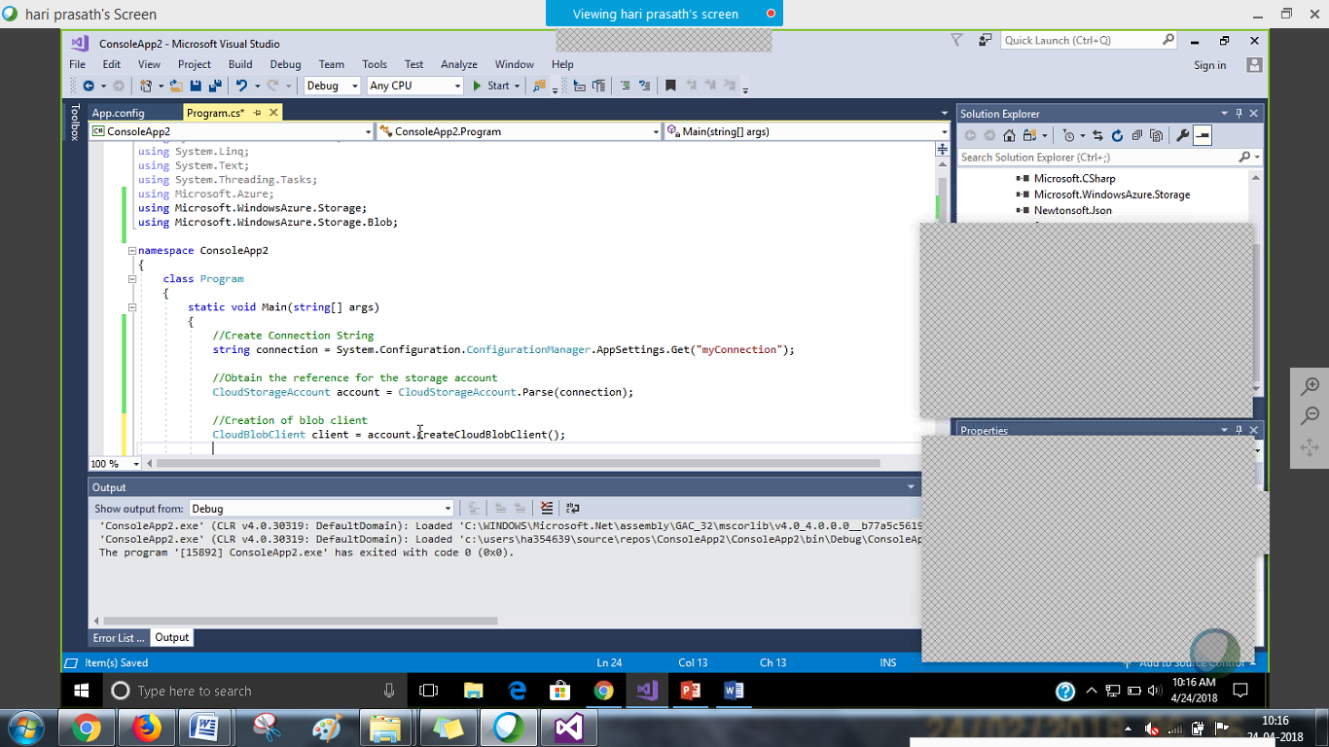

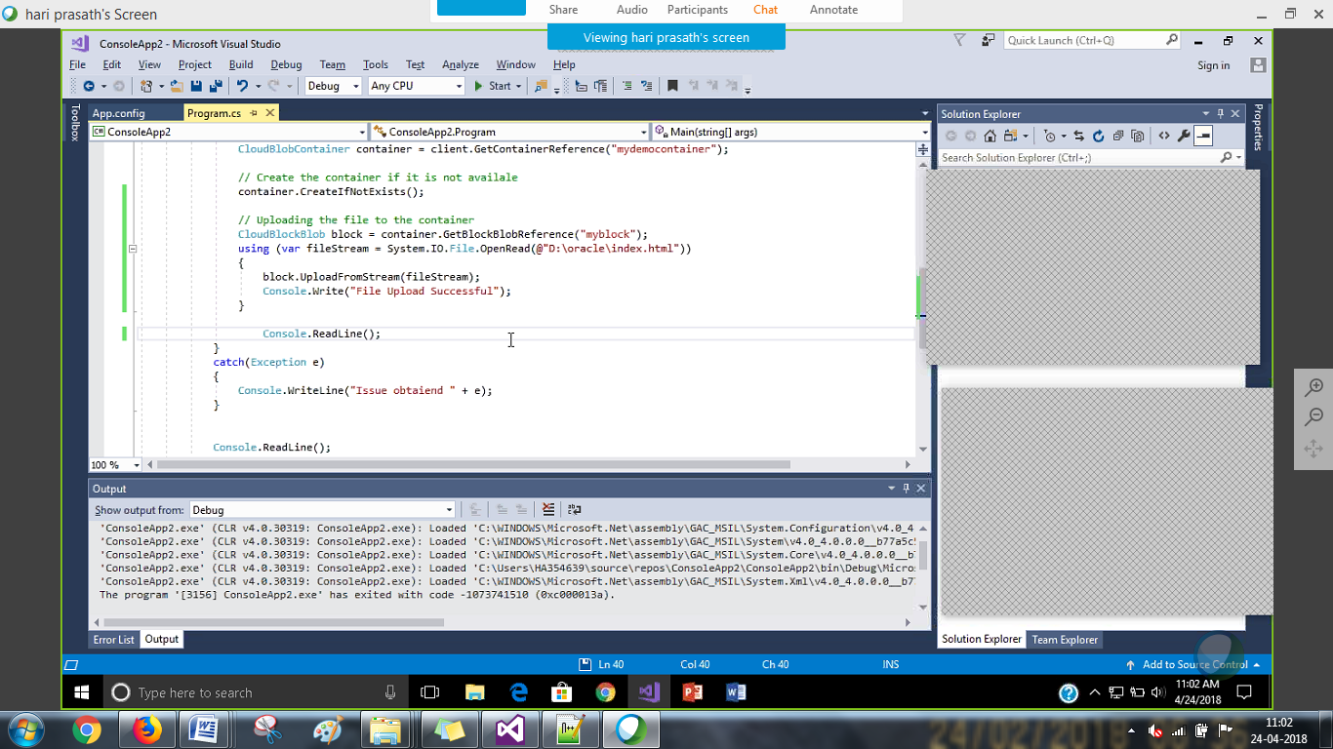

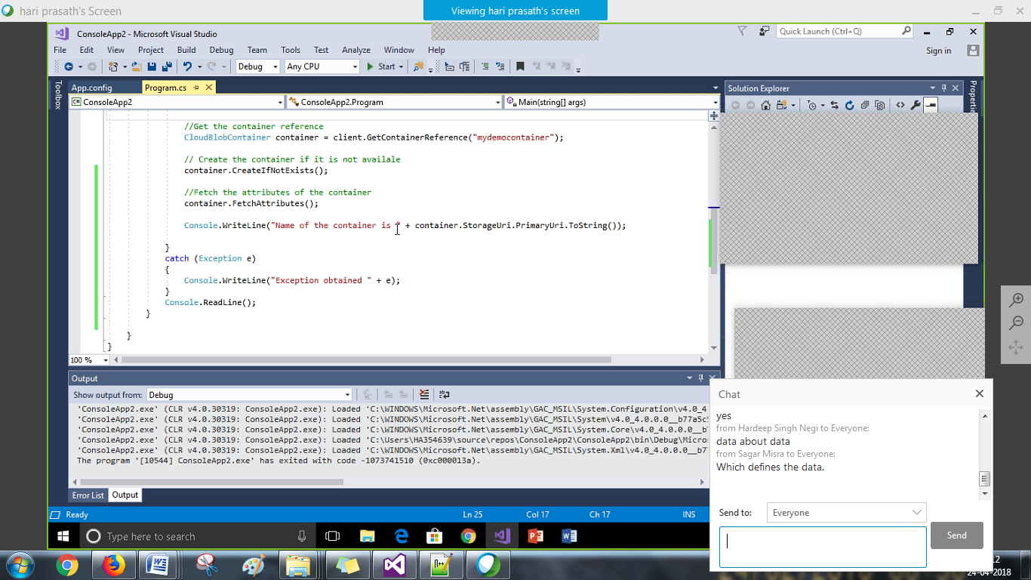

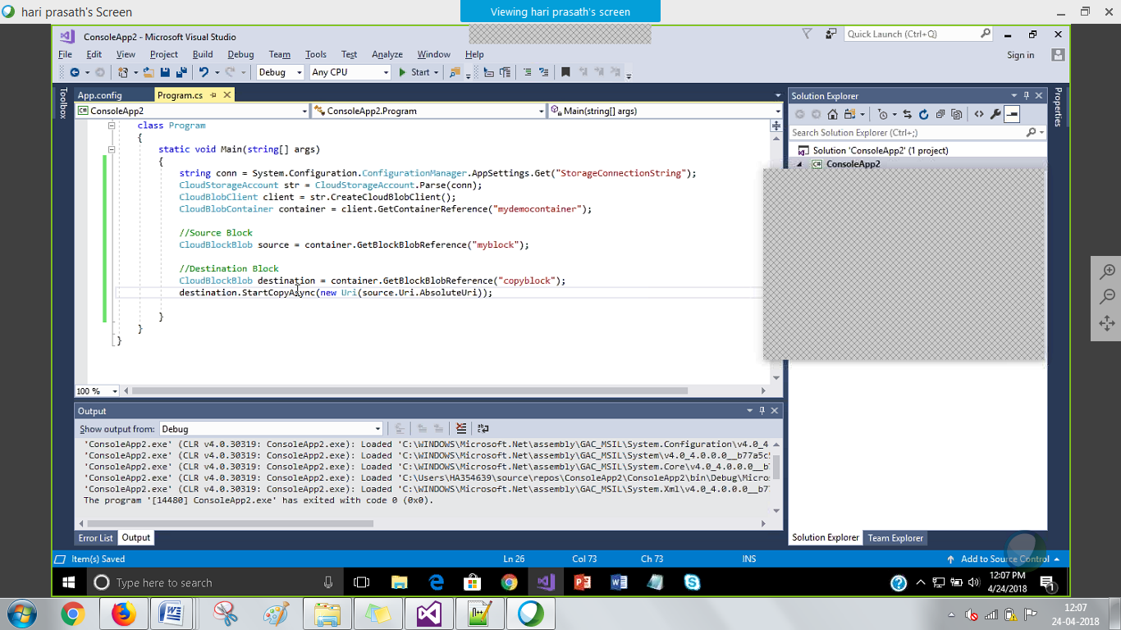

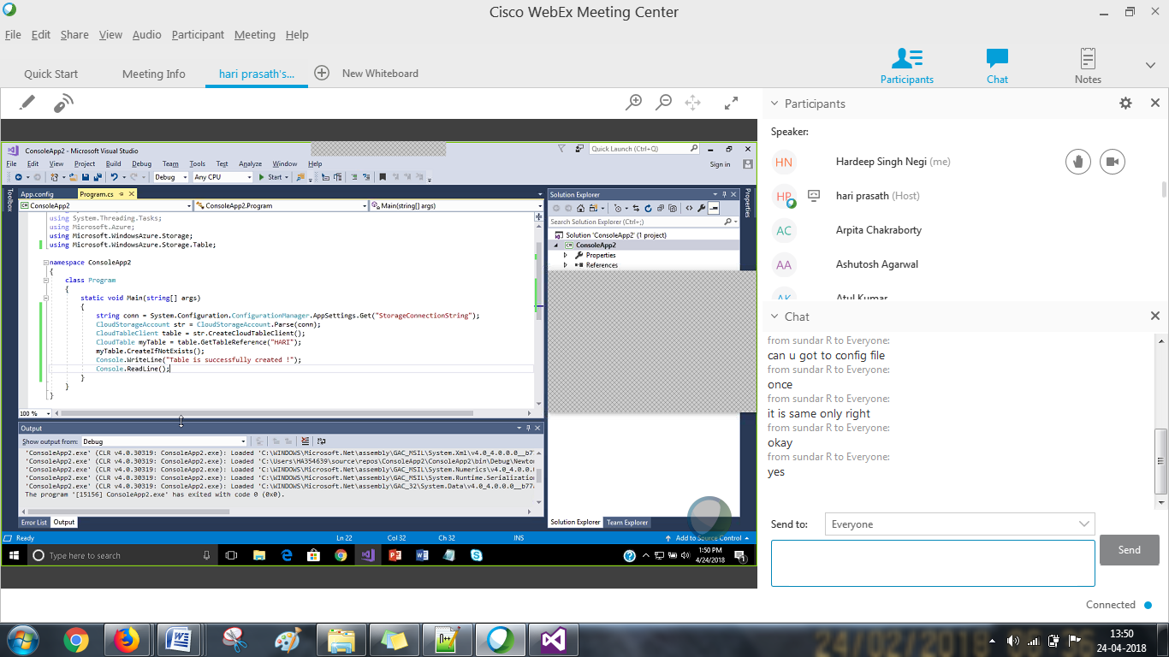

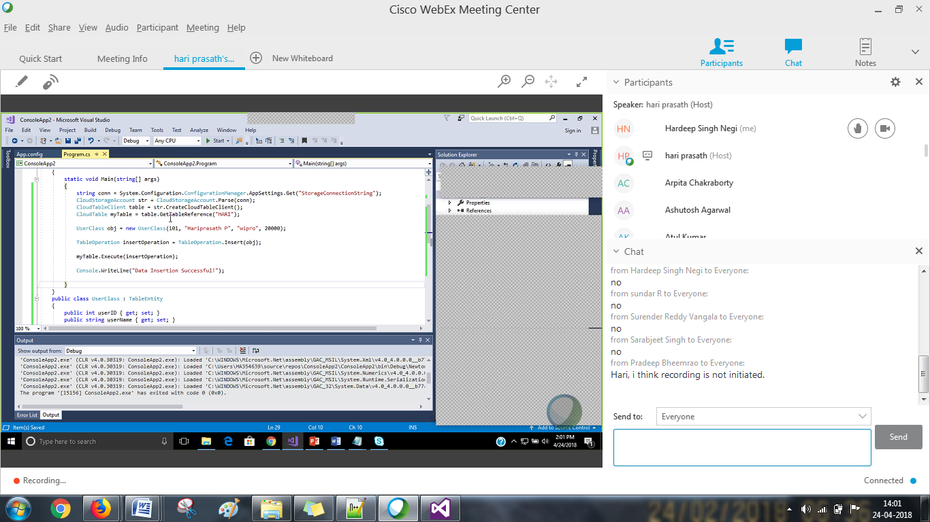

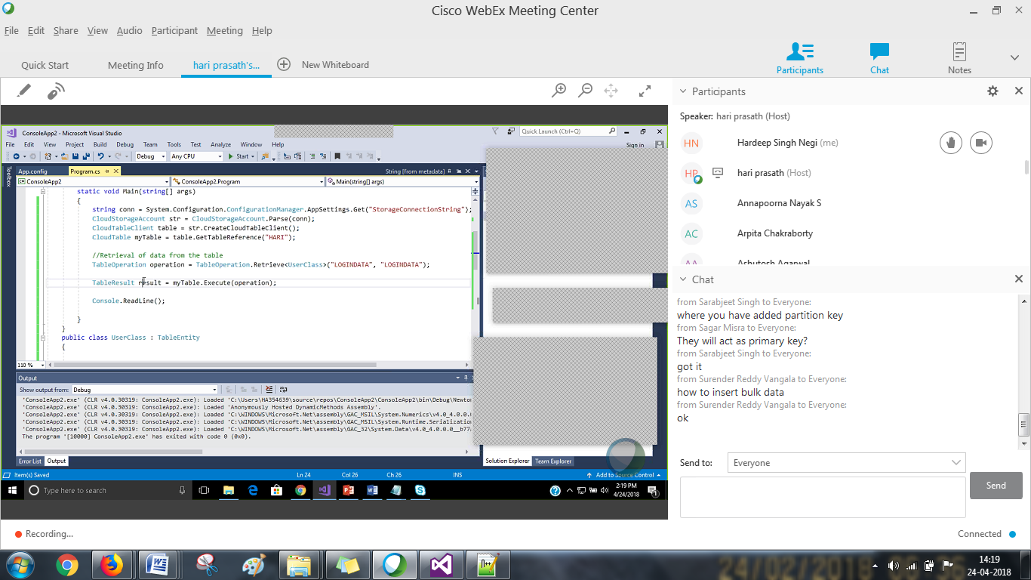

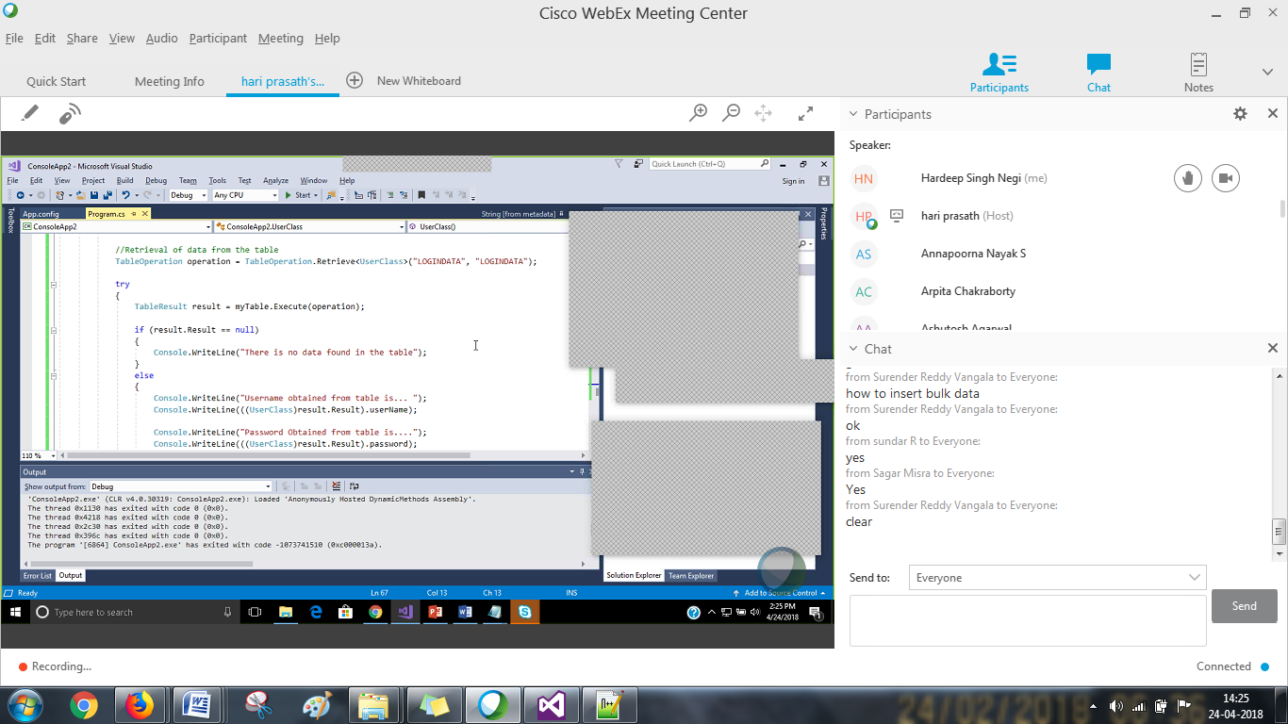

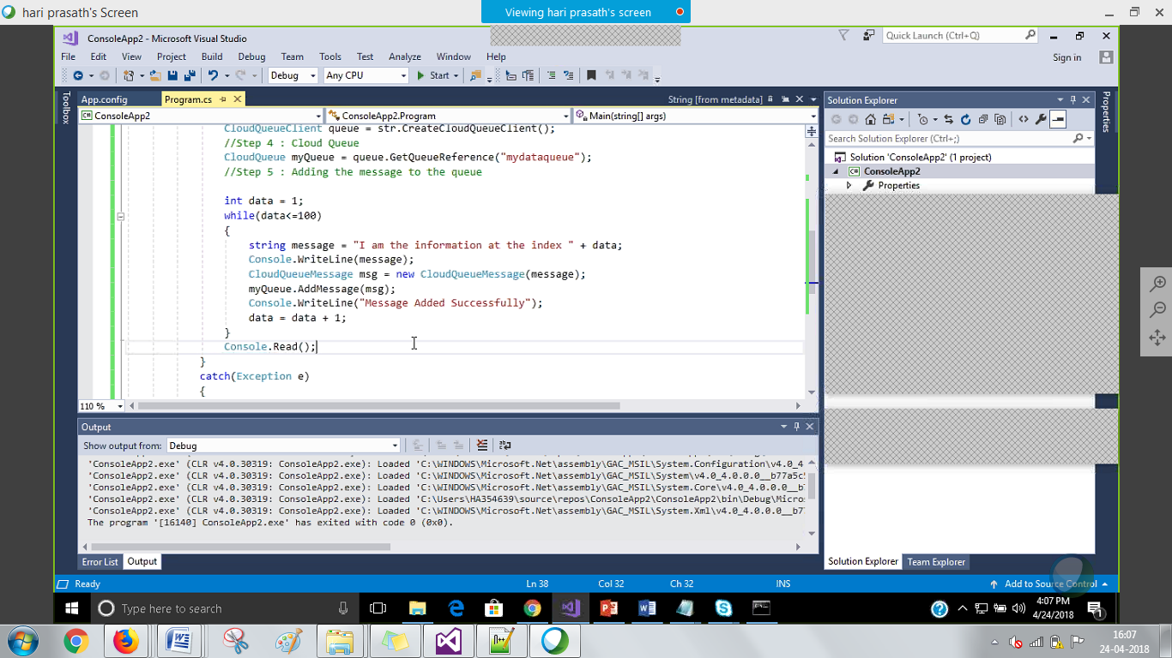

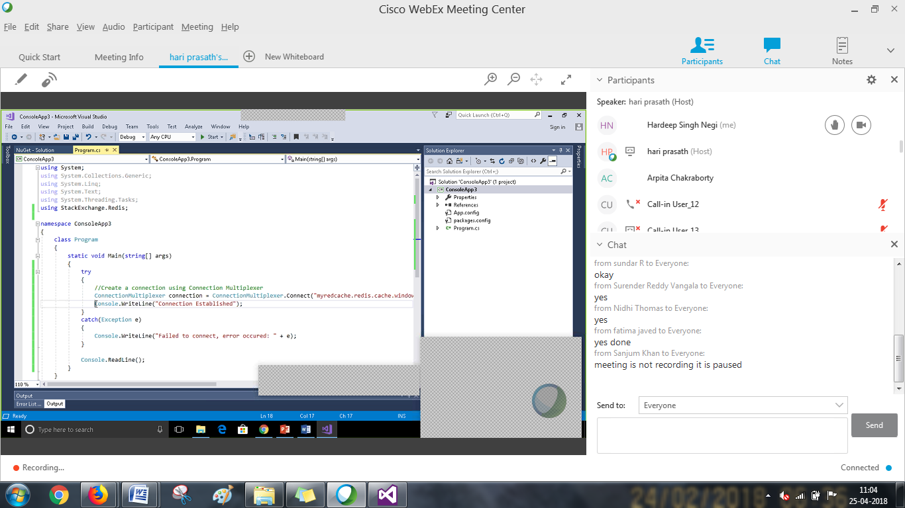

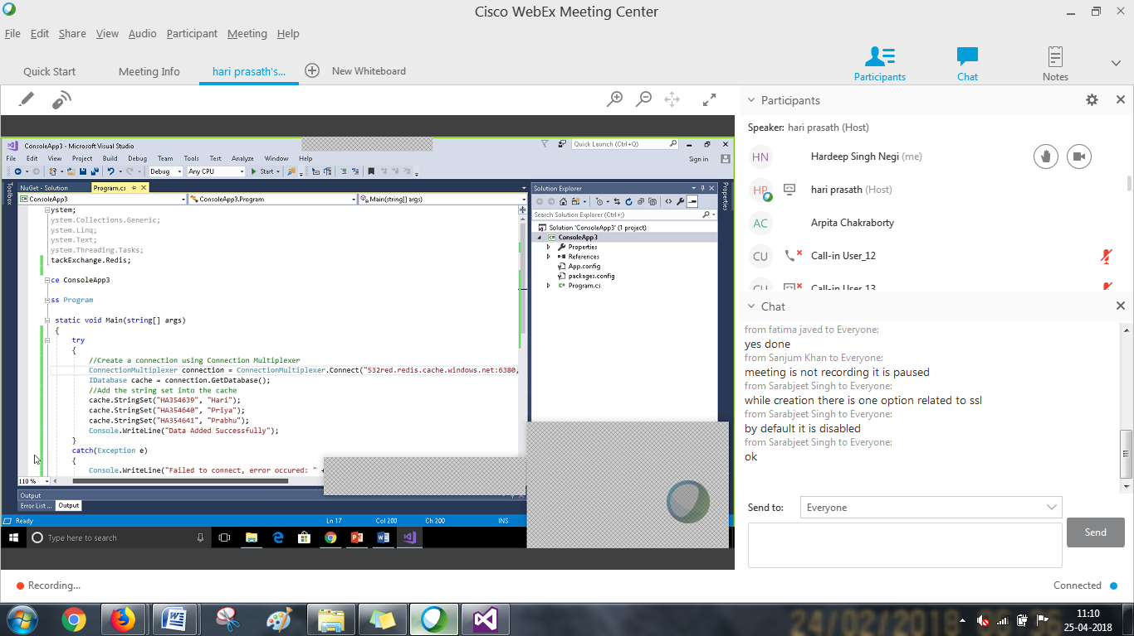

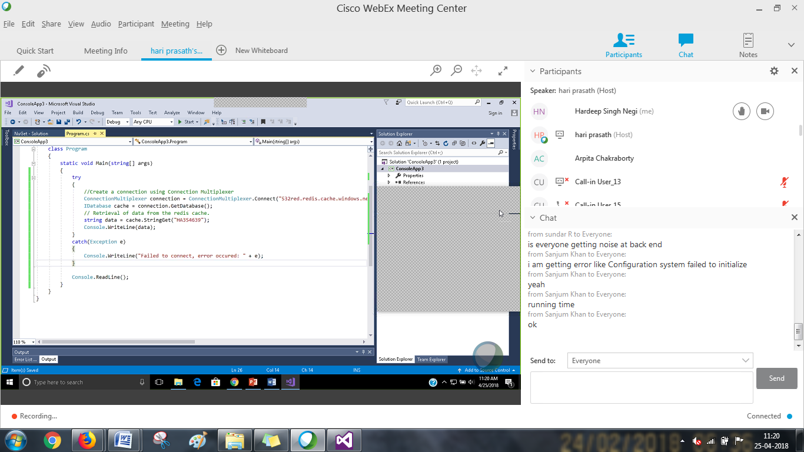

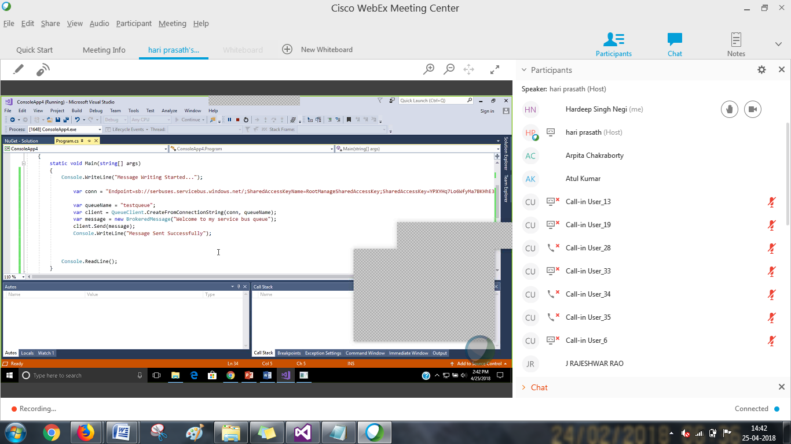

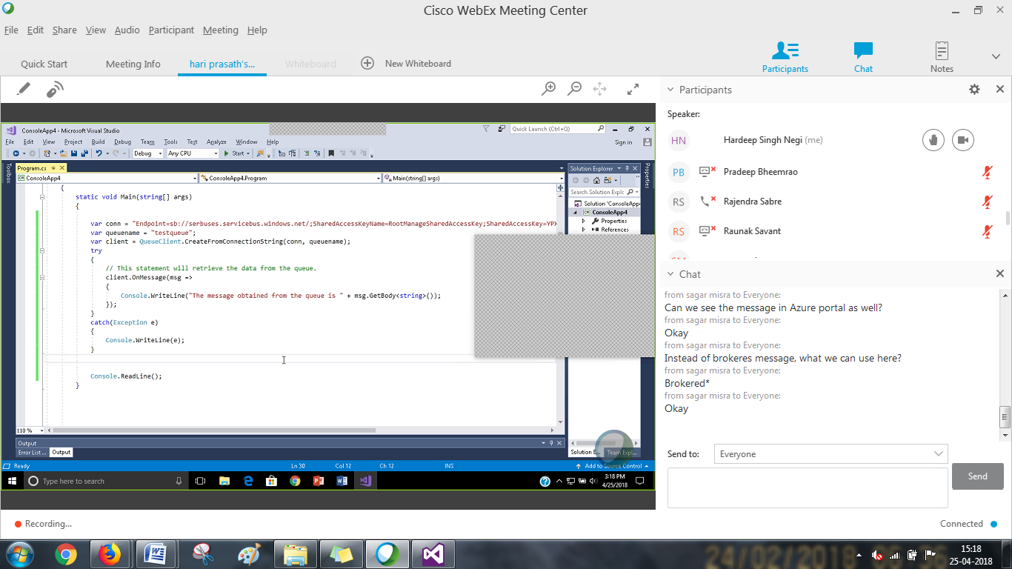

using System;

using Microsoft.ServiceBus.Messaging;

namespace servicebus

{

    class Program

    {

        static void Main(string[] args)

        {

            try

            {

                var con = "Endpoint=sb://hardeep.servicebus.windows.net/;SharedAccessKeyName=RootManageSharedAccessKey;SharedAccessKey=+pz5h2H/8yy7C5hiPa3kEEXnrvyYV6sgsFySetulDl0=";

                var queuename = "testingque";

                var client = QueueClient.CreateFromConnectionString(con, queuename);

                //var message = new BrokeredMessage("helllo");

                //client.Send(message);

                //Console.WriteLine("Message sent");

                client.OnMessage(msg =>

                {

                    Console.WriteLine("Message in the queue was:" + msg.GetBody<string>());

                });

                Console.ReadKey();

            }

            catch (Exception e)

            {

                Console.WriteLine(e);

            }

        }

    }

}

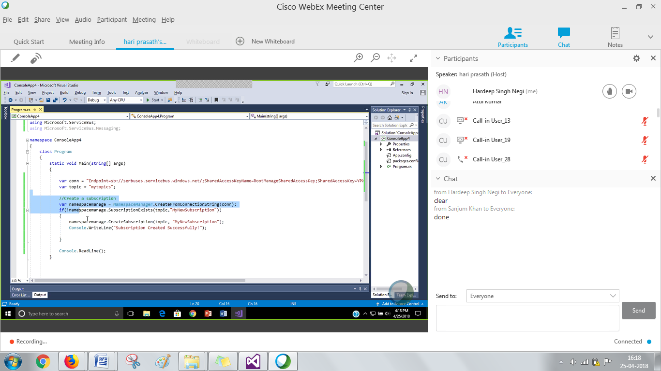

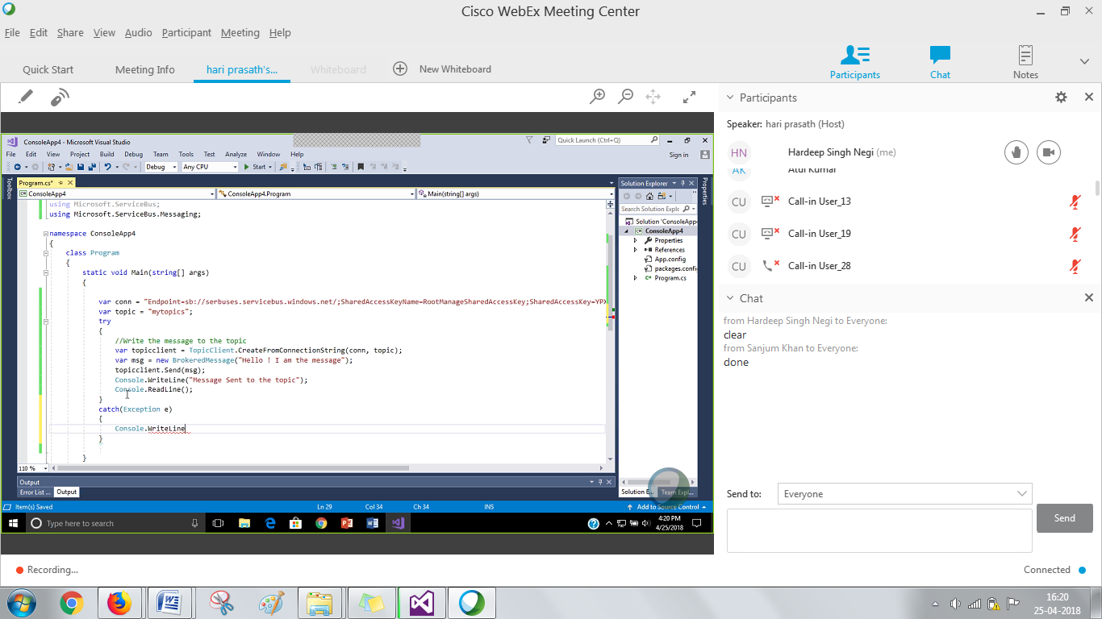

using System;

using Microsoft.ServiceBus.Messaging;

using Microsoft.ServiceBus;

namespace Topic

{

    class Program

    {

        static void Main(string[] args)

        {

            var con = "Endpoint=sb://hardeep.servicebus.windows.net/;SharedAccessKeyName=RootManageSharedAccessKey;SharedAccessKey=+pz5h2H/8yy7C5hiPa3kEEXnrvyYV6sgsFySetulDl0=";

            var topic = "mytopic";

            //var namespacemanage = NamespaceManager.CreateFromConnectionString(con);

            //if (!namespacemanage.SubscriptionExists(topic, "mysubscription"))

            //{

            //    namespacemanage.CreateSubscription(topic, "mysubscripiton");

            //    Console.WriteLine("created");

            //}

        }

    }

}

using System;

using Microsoft.ServiceBus.Messaging;

using Microsoft.ServiceBus;

namespace Topic

{

    class Program

    {

        static void Main(string[] args)

        {

            var con = "Endpoint=sb://hardeep.servicebus.windows.net/;SharedAccessKeyName=RootManageSharedAccessKey;SharedAccessKey=+pz5h2H/8yy7C5hiPa3kEEXnrvyYV6sgsFySetulDl0=";

            var topic = "mytopic";

            try

            {

                var topiclient = TopicClient.CreateFromConnectionString(con, topic);

                var msg = new BrokeredMessage("Message in a my subscription");

                topiclient.Send(msg);

                Console.WriteLine("Message added");

                Console.ReadKey();

            }

            catch (Exception)

            {

                throw;

            }

            Console.ReadKey();

        }

    }

}

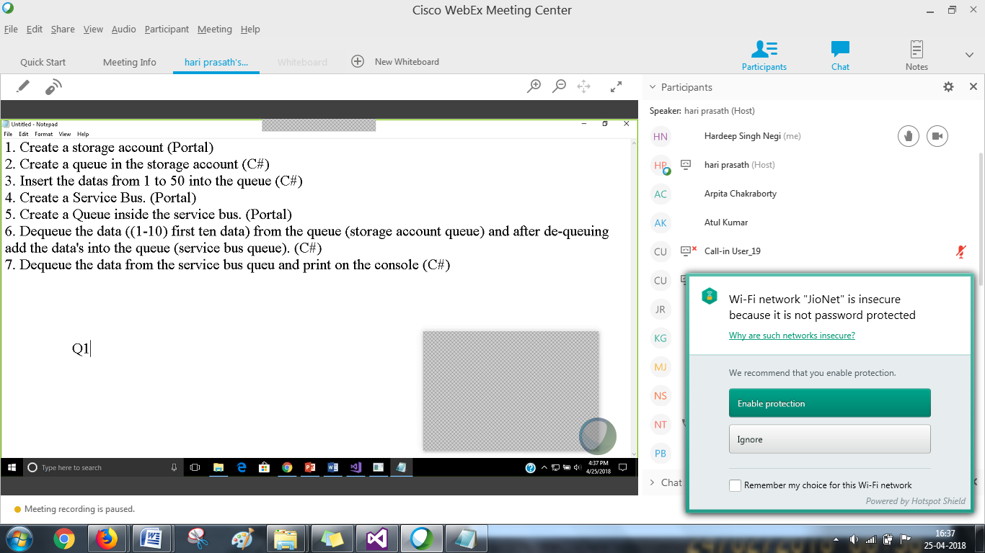

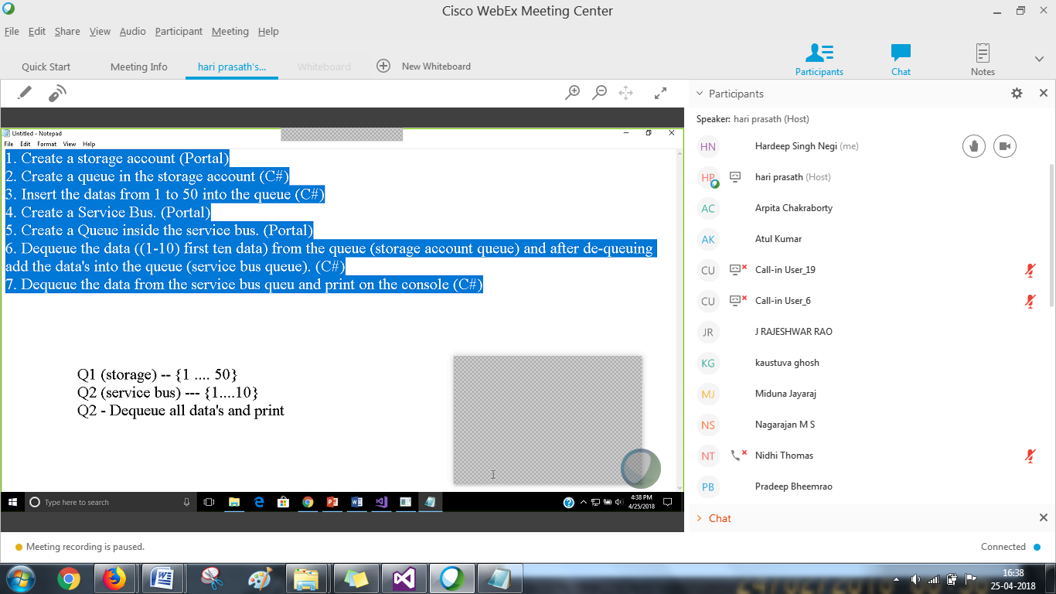

1. Create a storage account (Portal)2. Create a queue in the storage account (C#)3. Insert the datas from 1 to 50 into the queue (C#)4. Create a Service Bus. (Portal)5. Create a Queue inside the service bus. (Portal)6. Dequeue the data ((1-10) first ten data) from the queue (storage account queue) and after de-queuing add the data's into the queue (service bus queue). (C#)7. Dequeue the data from the service bus queu and print on the console (C#)

